**JAVASCRIPT ANIMATION**

**Lab:** Scrolling Images

Web page to music albums

**REQUIREMENTS**

* Notepad Editor
* Cover flow.css .file
* Cover flow.js.file
* Sly.min.js.file
* Jquery.mim.js.file
* Images to scroll (at least 5) each with thumbnails (smaller versions). Use images of albums
* My style.css

**PROCEDURE:**

**Step1: HTML**

Create your web page in Html. (Describing your albums)

Use a table to organize your content on the page.

**Step 2: CSS**

Add some style to your web by linking it to Mystyle.css. Note you are free to edit and make changes to the styling preferences of the file provided.

**Step 3: Scrolling Images banner**

Linking your web page to coverflow.css, coverflow.Js, Sly.mim.Js and Jquery.min.Js. Modify the coverflow.Js with your images providing a description of the musical albums.

*Note the bar should hold what you consider the latest albums.

**Step 4:**

Test your page and Debug

Appendix

Below is a screen shot of the scroll bar with images

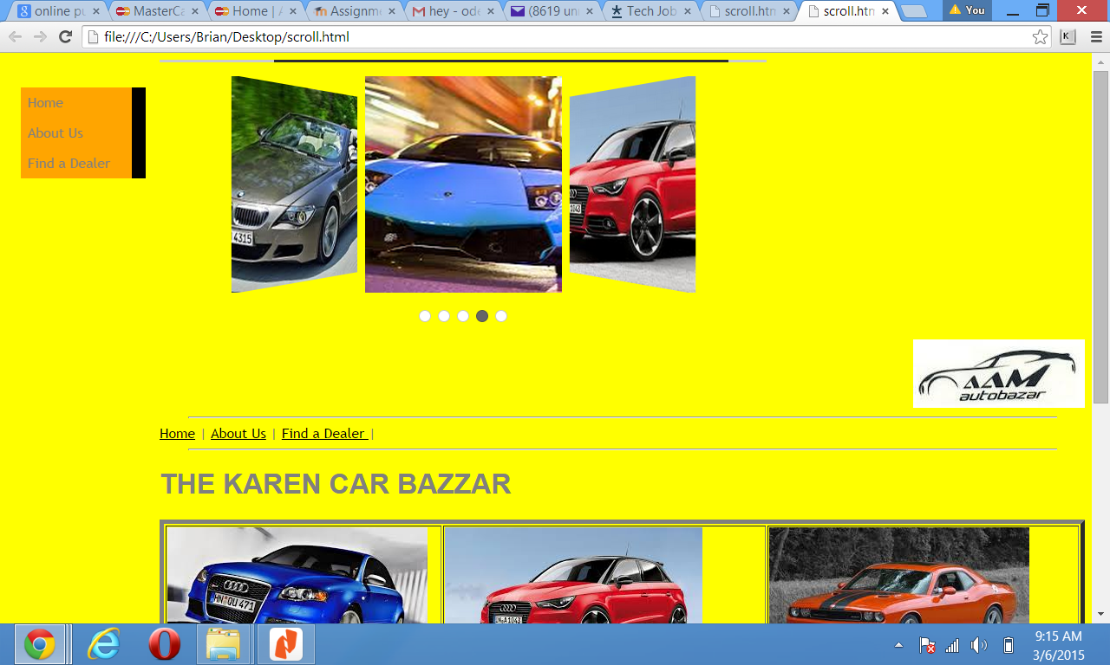

Hint on the code

|  |
| --- |
| <html> |
|  | <head> |
|  | <link rel="stylesheet" href="coverflow.css" /> |
|  | <link rel="stylesheet" href="Mystyle.css" /> |
|  | <script src="jquery.min.js"></script> |
|  | <script src="sly.min.js"></script>  <script src="coverflow.js"></script> |
|  | <meta name="viewport" content="width=device-width" /> |
|  |  |
|  | </head> |
|  |  |
|  |  |
|  | <body> |
|  | <div class="wrap" id="coverflow1"> |
|  |  |
|  | <div class="scrollbar"> |
|  | <div class="handle"> |
|  | <div class="mousearea"></div> |
|  | </div> |
|  | </div> |
|  |  |
|  | <div class="frame coverflow"> |
|  | <ul class="clearfix"> |
|  | <li>Holder</li> |
|  | </ul> |
|  | </div> |
|  |  |
|  | <ul class="pages"></ul> |
|  |  |
|  | </div> |
|  |  |
|  | <div> |
|  | <img align ="right" src= "mainlogo.jpg"><br><br><p><br> |
|  | <hr width= "1000"> |
|  | <a href= autobazzar.html>Home</a> | <a href= "aboutus.html">About Us</a> | <a href= "finddealer.html"> Find a Dealer </a> | <hr width= "1000"> |
|  | <h1> THE KAREN CAR BAZZAR</h1> |
|  | <p> |
|  | <UL class="navbar"> |
|  | <li>Home</li> |
|  | <li>About Us</li> |
|  | <li>Find a Dealer</li> |
|  | </UL> |
|  | <table border ="5"> |
|  | <tr><td><img src="AUDI A4.jpg"></td><td><img src="AUDI.jpg"> |
|  | </td><td><img src= "DODGE CHALLENGER.jpg"</td></tr> |
|  | <tr><td align = center><font type= "comic sans" color = "green"> |
|  | Audi A4 2011 model Price 11500 usd CIF mombasa</font></td> |
|  | <td><font type= "comic sans" color = "green">Audi R8 coupe 2013 model Price 17000 usd CIF Mombasa</font></td> |
|  | <td><font type= "comic sans" color = "green">The Dodge Chellenger 1999 model price 15000 usd CIF mombasa</font></td></tr> |
|  | <tr><td><img src= "MUSTANG.jpg"></td><td><img src= "bmw.jpg"></td><td><img src="LAMBOGINI.jpg"></td></tr> |
|  | <tr><td>The Ford Mustang 500 price 18340 usd CIF Mombasa</td> |
|  | <td>The BMW M3 Convertible 2009 model price 20110 usd CIF Mombasa </td> |
|  | <td>Lambigini Matador 2009 model Price 23400 usd CIF Mombasa</td></tr> |
|  | </table> |
|  | <p> |
|  | our offices are at the juction towards Hardy Police Station |
|  | </div> |
|  |  |